**InQuire**

**User Guide**

**Rev. <0.5> Approved**

**Prepared by David Yu**

**<11/24/2016>**

**Insyde Software Corp.**

Copyright (c) 1998-2016, All Rights Reserved.

Insyde Software Corp.

No part of this publication may be reproduced, transmitted, transcribed, stored in a retrieval system, or translated into any language or computer language, in any form, or by any means, electronic, mechanical, magnetic, optical, chemical, manual or otherwise, without the prior written permission of Insyde Software Corp.

**Disclaimer**

Insyde Software Corp. provides this document and the programs "as is" without warranty of any kind, either expressed or implied, including, but not limited to, the implied warranties of merchantability or fitness for a particular purpose.

This document could contain technical inaccuracies or typographical errors. Changes are periodically made to the information herein; these changes will be incorporated in future revisions of this document. Insyde Software Corp. is under no obligation to notify any person of the changes.

The following trademarks are used in this document:

 is a registered trademark of Insyde Software Corp.

All other trademarks or trade names are property of their respective holders.

**Revision History**

|  |  |  |  |  |
| --- | --- | --- | --- | --- |
| **Rev.** | **Date** | **Author** | **Approver** | **Summary** |
| 0.1 | <03/22/2016> | David Yu |  | Initial Version |
| 0.2 | <06/17/2016> | David Yu |  | Add more information for new function support. |
| 0.3 | <07/06/2016> | David Yu |  | Revise and add information |
| 0.4 | <08/30/2016> | David Yu |  | Revise and add information |
| 0.5 | <11/24/2016> | David Yu |  | Revise and add information  1.File center 2. Super search 3. Message center |
|  |  |  |  |  |
|  |  |  |  |  |
|  |  |  |  |  |
|  |  |  |  |  |
|  |  |  |  |  |
|  |  |  |  |  |
|  |  |  |  |  |

**Table of Contents**

1. Introduction 1

1.1 Overview 1

1.2 Reference 2

1.2.1 Definitions, Glossaries, Acronyms, Abbreviations 2

2. Getting Started with InQuire 3

2.1 Requirement for InQuire Tool 4

2.2 Account information for InQuire 4

2.3 Home page 5

2.4 3D-Pub 6

2.5 CODE 7

2.6 ITS 8

2.7 TOD 9

2.8 File Center 10

2.9 Super Search 11

2.10 Message Center 12

3. Live update 13

# Introduction

InQuire is a program that provides easy, centralized access to all of Insyde Software's online cloud services.

## Overview

This document will provide an overview of using InQuire as well as describe the services you can access from it.



**InQuire benefits**

* Convenience – integrate Insyde software services into one utility.
* Faster Logins – Use only one login for all service functions.
* Enhancing service efficiency can help improve the overall development experience.

## 1.2 Reference

The following publications and sources of information may be useful to you.

### Definitions, Glossaries, Acronyms, Abbreviations

|  |  |
| --- | --- |
| **Term** | **Description** |
| **ITS** | **I**ssue **T**racking **S**ystem |
| **SVN** | Subversion for source version control system |
| **TOD** | Training on Demand |

# Getting Started with InQuire

When you have completed the InQuire installation process through the InQuire installer package, the program should successfully launch for the first time. You will be greeted by InQuire's home page, which will show the following tabs at the top that provide quick access to our services:

* **3D-Pub**: Retrieve information from subscribed publications through this service (Web Version)
* **CODE**: Review authorized of source code repository.
* **ITS:** Report issues to Insyde and track it via ITS.
* **TOD:** Training On Demand. Learn from training videos provided by Insyde Software.
* **File Center:** Download available tool package and document.
* **Super search:** Assist to search out related information in 3D-Pub and ITS service via key word.
* **Message Center:** Notice newest publication message.

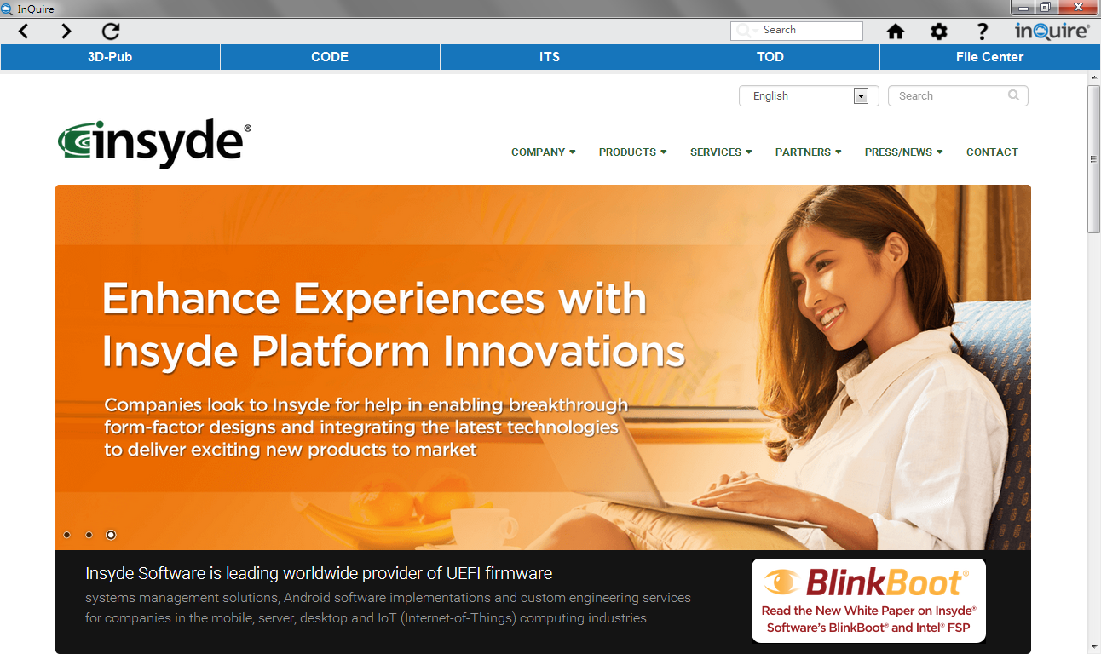

## 2.1 Requirement for InQuire Tool

* Have a current account and password for 3D-pub, ITS/WTS, Code/SVN and VPN.
* PC Environment: Microsoft Windows 7 and later are supported.

## 2.2 Account information for InQuire

After setup has finished via the installer and before executing the first launch of the tool, InQuire will request the account information for all supported Insyde services. To continue, please provide a master password for InQuire (which is required to open and use InQuire securely) and fill in all account

information for the Insyde services you wish to access via InQuire.

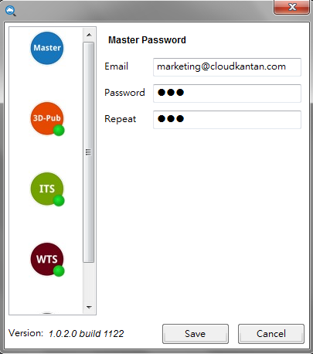

The following account settings are requested for each service function.

* **Master password**:
* Please input your e-mail.
* The master password is requested when entering InQuire. Please input your master password.
* **3D-Pub**: Used when logging into 3D-pub service.
* **ITS/WTS**: Used when logging into ITS service.
* **CODE/SVN**: Used when logging into CODE/SVN service.
* **VPN**: Used when logging into VPN to connect to Insyde services from an external location.

## 2.3 Home page

The following is the main page of InQuire that shows relevant information (such as Insyde software's web site) when you login to InQuire or use the home button.



## 2.4 3D-Pub

3D-Pub is publication service page that can retrieve information from subscribed publications through this service. In order to easy query information, there are related nodes of classifying information in tree view on left side. When you click one of nodes in the tree view you would like to query, it will present related information on a publication list.

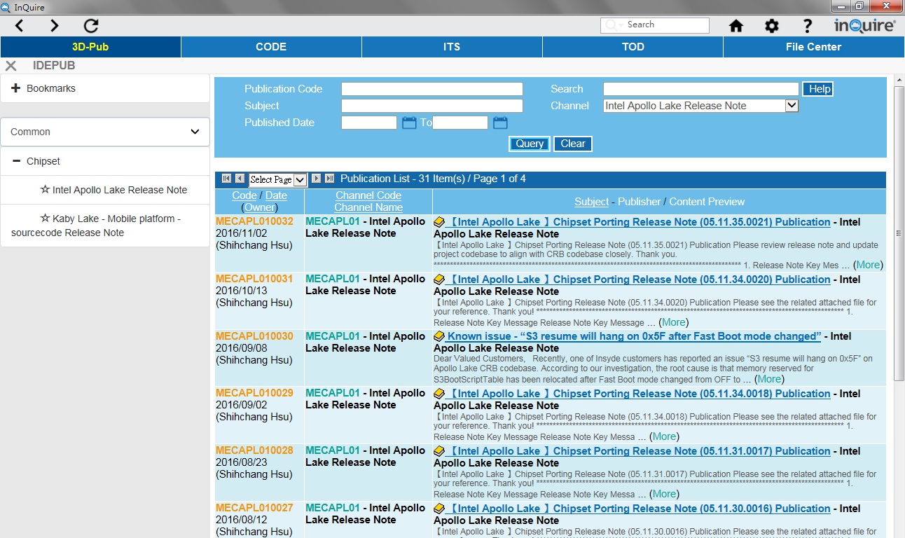

## 2.5 CODE

CODE is a source code repository list page that allows authorized review of each source code repository.

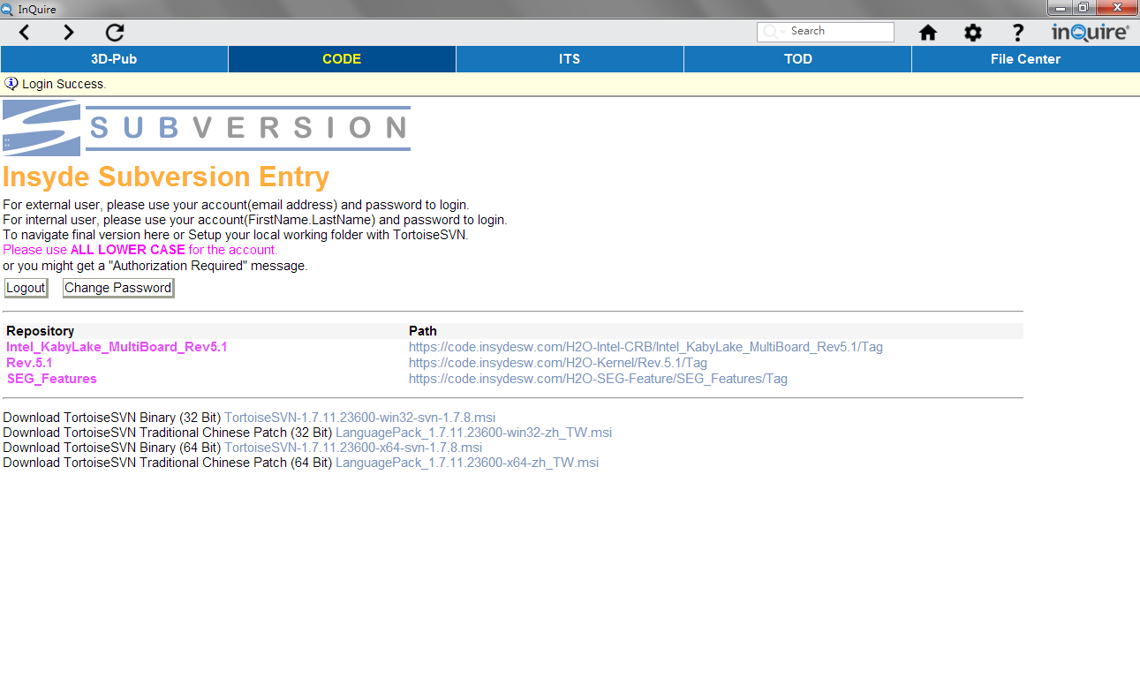

## 2.6 ITS

The ITS service page can report issues to Insyde Software and help track it.

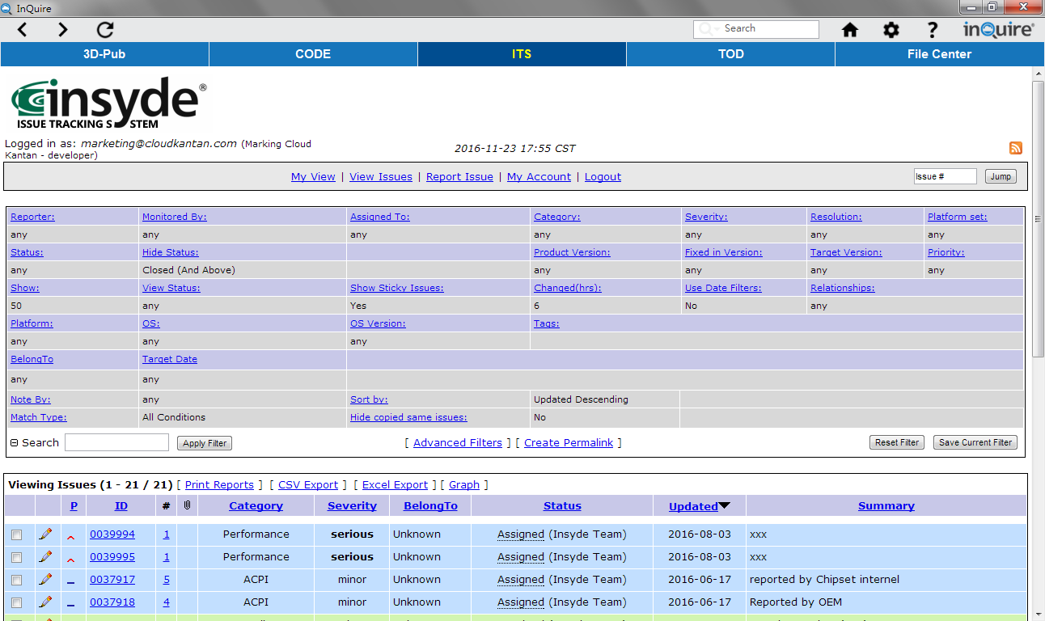

## 2.7 TOD

TOD (Training on Demand) service provides online developer training courses from Insyde Software. Select from available training subject via playlists and play them from InQuire.

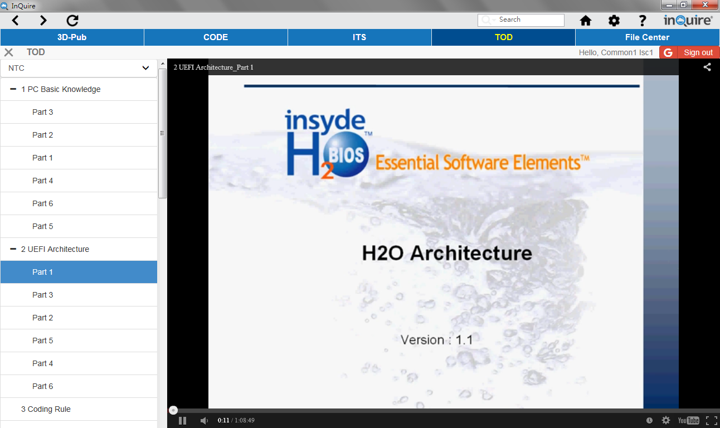

## 2.8 File Center

File Center service provides online to download related tool package or document from Insyde Software. Select from available package or document via classified list and download from file center to local disk.

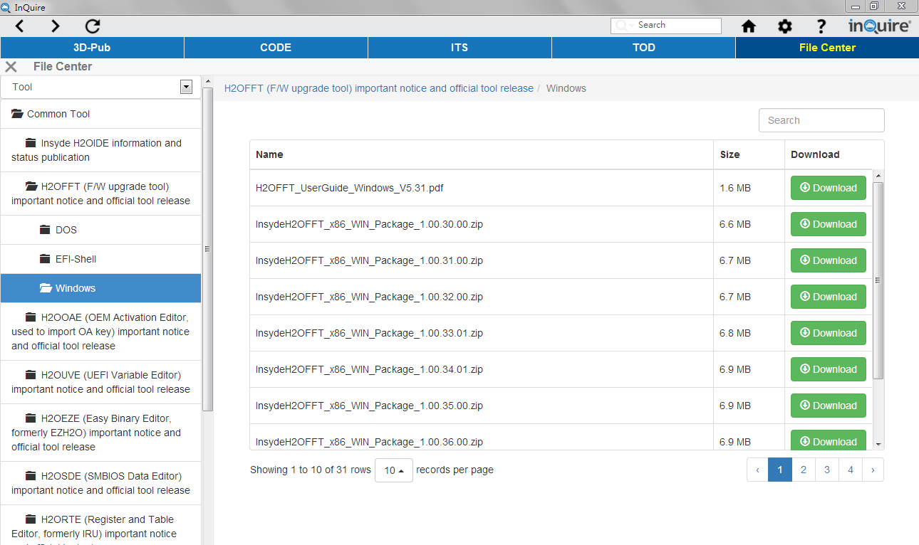

## 2.9 Super Search

Super search can assist to search out related information in 3D-Pub and ITS service via key word.

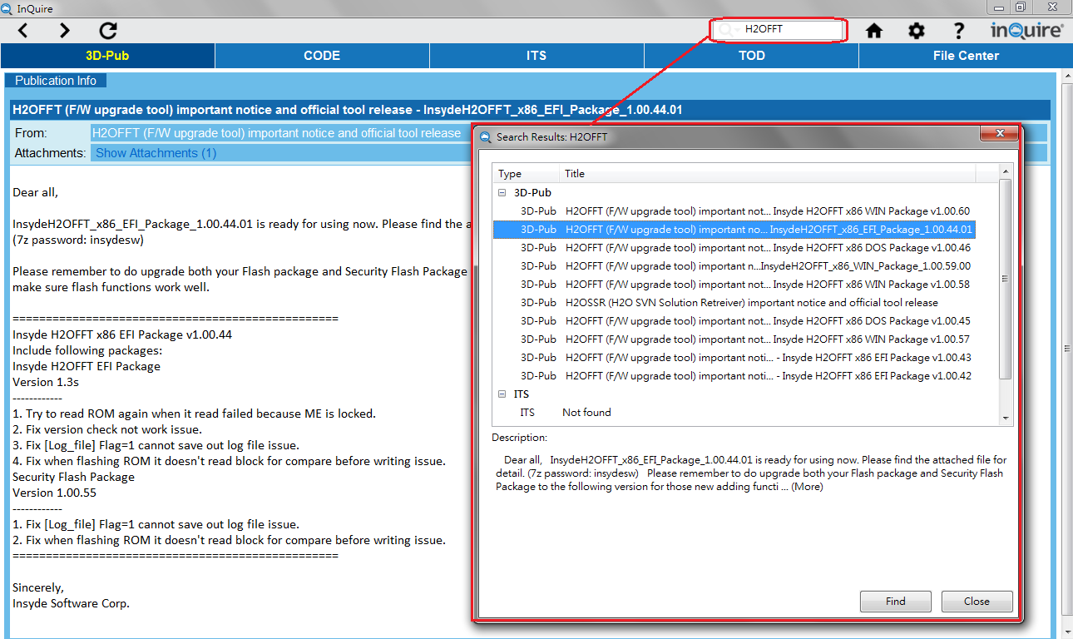

## 2.10 Message Center

Message center will automatically pop on corner of right bottom and notice how many newest publications message are available. Select url link on message will redirect to 3D-Pub service page for detail description.

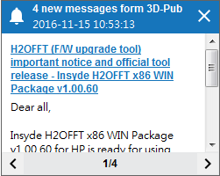

# 3. Live update

Insyde Live Update is used to automatically make sure that all InQuire utilities are up-to-date via the

internet. When a new version is available, users will get an update notice from Insyde Live Update icon

that will be visible from the Windows task bar.

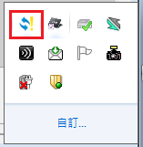

You can also manually use the right mouse button on the Insyde Live Update icon and hit “Immediately

Update” to perform the update process.

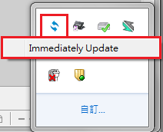

When there are available updates, the latest version of InQuire and other related Insyde tools will be

listed in Insyde Live Update Window. Select which tools you would like to update and then start the

update process by pressing the "Update" button.

